**THE UNIVERSITY OF DODOMA**



**COLLEGE OF INFORMATICS AND VIRTUAL EDUCATION**

**DEPARTMENT OF COMPUTER SCIENCE AND ENGINEERING**

**FINAL YEAR PROJECT PROPOSAL**

### ACADEMIC YEAR: 2023/2024

### TITLE: SMART SCHEDULING AND MANAGING APPLICATION FOR QUEUE SOLUTIONS AND ENHANCING WOMEN SATISFACTION IN HAIR SALONS

GROUP MEMBERS

|  |  |  |
| --- | --- | --- |
| **NAME** | **REG NUMBER** | **PRORAMME** |
|  |  |  |
|  |  |  |
|  |  |  |
|  |  |  |
|  |  |  |

**NAME OF SUPERVISOR SIGNATURE**

**Mr. ------------------------------------ ------------------**

# CHAPTER 1

INTRODUCTION

### Project Overview

In today's fast-paced world, the demand for efficient and convenient hair salon services is on the rise. However, traditional appointment scheduling and queue management systems often fall short in meeting the needs of both customers and salon owners. To address this gap, we propose the development of a Smart Scheduling and Managing Application tailored specifically for hair salons.

### Problem statement

Hair salons are a vital part of the culture and economy of our country. However, they face many challenges, such as long waiting times, lack of customer loyalty, low profitability, and poor service quality. These challenges affect both the customers and the salon owners, who often struggle to meet the demand and expectations of their clients. There is a need for an innovative IT solution that can address these challenges and improve the customer experience and the salon management.

## OBJECTIVES

### Main objective:

The project aims to develop a Web and mobile application that will implement a smart scheduling and managing application for queue solutions in hair salons with a specific focus on enhancing women's satisfaction. The proposed application will streamline the booking process, reduce wait times, and improve overall customer experience in hair salons, particularly targeting women. By leveraging technology, the project seeks to address common challenges faced by both salon owners and customers, ultimately leading to increased efficiency and satisfaction.

### Specific objectives:

1. To develop a user-friendly mobile application for hair salons to efficiently schedule and manage appointments.
2. **User-Centered Design Approach**: Employ a user-centered design approach to ensure the mobile application is intuitive, easy to navigate, and meets the specific needs of salon owners, staff, and customers. Conduct user research, interviews, and usability testing to understand user preferences, pain points, and workflow requirements. Incorporate feedback from salon owners throughout the development process to iteratively refine the application's design and functionality.
3. **Appointment Scheduling Features**: Implement robust appointment scheduling features that allow salon staff to efficiently manage their calendar, customer personal preferences, chosen hairstyles, preferred salons, hairstyles durability, specific time slots and view availability in real-time. Include options for specifying service types, duration, contact details, staff preferences, and any additional notes or special requests from clients. Enable automatic reminders and notifications to confirm appointments and reduce no-shows.
4. **Staff Management Tools**: Integrate staff management tools to streamline communication and coordination among salon employees. Provide features for assigning appointments to specific staff members, managing their schedules, and tracking their availability. Include functionalities for staff to view their upcoming appointments, set their availability preferences, and communicate any scheduling conflicts or changes.
5. **Client Database and Profile Management**: Develop a client database and profile management system with customizable settings and preferences to store essential information about salon clients, such as contact details, service history, preferences, and notes in the mobile application for hair salons this adds a layer of personalization and convenience for users. Enable staff to easily access client profiles, view their past appointments, and personalize their service offerings based on individual preferences and needs. Implement security measures to protect sensitive client information and ensure compliance with data privacy regulations.
6. To implement Smart Queuing Algorithms to Minimize Wait Times and Optimize Staff Resources.
7. **Dynamic Queue Management**: Implement a dynamic queuing system with a certain float that continuously updates based on real-time data, such as walk-in customers, cancellations, and no-shows, appointment times, service durations, and peak hours. The algorithm will prioritize appointments based on urgency, service complexity, and staff availability to minimize wait times and maximize resource utilization.
8. **Staff Allocation Optimization**: Develop algorithms to optimize staff assignments based on skill levels, experience, and availability. By matching staff expertise with customer needs, the system can ensure efficient service delivery and minimize idle time for employees. This will keep both salon staff and clients informed about appointment status, changes, and reminders. Implement push notifications to notify clients of upcoming appointments, confirmations, or any schedule adjustments. Provide staff with instant notifications of new bookings, cancellations, or changes in the schedule to facilitate smooth operations and minimize disruptions.
9. **Integration with Customer Preferences**: Incorporate customer preferences and historical data into the queuing algorithms to personalize the salon experience. For example, the system can prioritize appointments with preferred stylists or recommend complementary services based on past bookings and feedback.

Implementing these smart queuing algorithms will not only minimize wait times and optimize staff resources but also enhance the overall efficiency and effectiveness of the salon's operations.

1. To enhance customer satisfaction by providing personalized service options and real-time updates on appointment status.
2. **Personalized Service Options**:

***Customer Profiles***: Develop a feature within the application that allows customers to create profiles where they can input their preferences, such as preferred stylist, preferred services, preferred appointment times, and any special requests or allergies.

***Recommendation Engine***: Implement a recommendation engine that analyzes customer profiles and booking histories to suggest personalized service options. For example, if a customer frequently books hair coloring services, the application can recommend complementary services like hair treatments or styling options.

***Customization Features***: Provide customers with the ability to customize their appointments based on their preferences. This could include selecting specific services, choosing preferred products or brands, and specifying additional requirements or instructions.

1. **Real-time Updates on Appointment Status**:

***Staff Availability***: Provide visibility into staff availability and schedule changes to help customers make informed decisions when booking appointments. If a preferred stylist is unavailable, the application can suggest alternative options based on availability and customer preferences.

***Appointment Reminders***: Send automated appointment reminders to customers via push notifications to reduce no-shows and cancellations. Include relevant details such as appointment date, time, stylist name, and any special instructions.

***Queue Status Updates***: Allow customers to track their position in the queue and receive real-time updates on wait times. Implement a queue management system that displays estimated wait times and notifies customers when their turn is approaching.

1. **Integration of Feedback Mechanisms**:

***Post-Appointment Surveys***: Prompt customers to provide feedback after their appointments to evaluate their satisfaction levels and identify areas for improvement. Use this feedback to continuously enhance the salon experience and tailor services to meet customer expectations.

***Rating and Review System***: Implement a rating and review system where customers can rate their salon experience and provide written reviews. Display these ratings and reviews within the application to help other customers make informed decisions when choosing services and stylists.

1. **Customer Engagement and Loyalty Programs**:

***Special Offers and Promotions***: Use the application to communicate special offers, promotions, and seasonal discounts directly to customers. Tailor these offers based on customer preferences and past booking behavior to maximize relevance and effectiveness.

***Rewards and Incentives***: Offer rewards and incentives to encourage repeat business and foster customer loyalty. This could include loyalty points for every appointment booked, discounts on future services, or exclusive perks for VIP customers.

By providing personalized service options and real-time updates on appointment status, the salon can create a more tailored and convenient experience for customers. This not only enhances customer satisfaction and loyalty but also contributes to increased retention rates and positive word-of-mouth referrals, ultimately driving business growth and success.

1. To implement data analytics algorithms to track customer preferences and improve operational efficiency which in turn will empower salon owners.
2. **Data Collection and Integration**: Implement data collection mechanisms to gather information on customer preferences, behaviors, and service interactions. This can include capturing data from booking histories, service reviews, product purchases, and customer feedback. Integrate data from the scheduling application sources to create a comprehensive database of customer insights.
3. **Data Analysis and Visualization**: Develop data analytics tools and dashboards to analyze and visualize key metrics related to customer preferences and operational efficiency. Use techniques such as segmentation analysis, trend analysis, and correlation analysis to identify patterns and insights within the data. Visualize the findings through charts, graphs, and heat maps to make the information more accessible and actionable for salon owners.
4. **Customer Segmentation and Targeting**: Utilize data analytics to segment customers based on demographics, preferences, and purchasing behavior. By understanding the distinct needs and preferences of different customer segments, salon owners can tailor their marketing efforts, service offerings, and promotions to effectively target and engage each segment. For example, they can create personalized promotions for loyal customers or introduce new services based on emerging trends.
5. **Predictive Analytics and Forecasting:** algorithms based on feedback and performance metrics. By analyzing customer satisfaction ratings, wait time data, and staff productivity, the system can adapt and optimize its algorithms over time to better meet the needs of both customers and salon staff. Leverage predictive analytics techniques to forecast demand, anticipate trends, and optimize inventory management. By analyzing historical booking data and seasonal trends, salon owners can predict future demand for specific services and products, allowing them to adjust staffing levels, inventory levels, and promotional activities accordingly. This proactive approach helps minimize stock outs, reduce wastage, and maximize revenue opportunities.
6. **Operational Optimization and Decision Support**: Provide salon owners with actionable insights and recommendations to improve operational efficiency and decision-making. For example, analytics tools can identify inefficiencies in scheduling practices, recommend optimal staffing levels based on demand patterns, or highlight opportunities for upselling or cross-selling. By empowering salon owners with data-driven insights, they can make informed decisions to streamline their operations, enhance customer satisfaction, and drive business growth.

Empowering salon owners with data analytics tools not only enables them to gain deeper insights into customer preferences and operational performance but also empowers them to make informed decisions that drive business success and customer satisfaction. By harnessing the power of data-driven decision-making, salon owners can unlock new opportunities for growth, innovation, and excellence in service delivery.

1. To test and evaluate the usability, functionality, and performance of the mobile application with real users.
2. **User Testing Design**:

***Testing Environment***: Conduct usability testing in a controlled environment that mimics real-world scenarios. This could involve setting up a simulated salon environment or using a usability testing lab.

***Recruitment of Participants***: Identify a diverse group of participants, including potential customers and salon staff, to represent the application's target user base. Ensure that the sample includes individuals with varying levels of technological proficiency and familiarity with salon appointments.

1. **Usability Testing**:

***User Observations***: Observe participants as they interact with the application, noting any challenges, confusion, or positive experiences. Pay attention to how easily users can navigate the app, understand its features, and complete tasks.

***Task Scenarios***: Develop realistic scenarios that reflect common user tasks, such as booking appointments, modifying schedules, and accessing personalized recommendations. This helps evaluate the application's usability and user-friendliness in practical situations.

1. **Functionality Testing**:

***Error Handling***: Evaluate how the application handles errors, such as incorrect input, network issues, or unexpected user behavior. Ensure that error messages are clear and guide users towards resolving issues.

***Feature Validation***: Verify that all features and functionalities outlined in the project requirements are working as intended. Test appointment booking, queue management, staff scheduling, and any other critical functions to ensure they align with the application's objectives.

1. **Performance Testing**:

***Load Testing:*** Simulate a high volume of concurrent users to assess the application's performance under peak conditions. This helps identify potential bottlenecks and ensures that the system can handle the expected user load without degradation in performance.

***Response Time***: Measure the response time for key actions within the application, such as booking an appointment or loading personalized recommendations. A responsive and efficient application contributes significantly to a positive user experience.

1. **Feedback Collection**:

***User Interviews***: Conduct one-on-one interviews with participants to delve deeper into their experiences. Explore specific pain points, positive aspects, and suggestions for improvement. These qualitative insights provide valuable context to complement quantitative data.

***Surveys and Questionnaires***: Administer post-testing surveys or questionnaires to collect quantitative and qualitative feedback. Include questions about overall satisfaction, ease of use, and specific features. Use Likert scales, open-ended questions, and feedback prompts to gather detailed insights.

## PROJECT SIGNIFICANCE

The significance of the project lies in its potential to address several key challenges faced by hair salons and their customers, while also leveraging technology to enhance the overall salon experience. Here are some key aspects of the project's significance:

***Improving Operational Efficiency***: By developing a user-friendly mobile application for scheduling and managing appointments, the project aims to streamline salon operations and optimize staff resources. This can lead to reduced wait times, minimized scheduling conflicts, and improved overall efficiency in salon management.

***Enhancing Customer Satisfaction***: Through personalized service options and real-time updates on appointment status, the project seeks to enhance customer satisfaction and loyalty. By catering to individual preferences and providing transparent communication, customers are more likely to have a positive salon experience and become repeat clients.

***Empowering Salon Owners***: By providing salon owners with data analytics tools, the project empowers them to make informed decisions based on actionable insights. This can help salon owners better understand customer preferences, optimize resource allocation, and identify opportunities for improvement, ultimately leading to increased profitability and sustainability.

***Promoting Innovation and Adaptability***: The project fosters innovation within the salon industry by introducing smart queuing algorithms, personalized recommendation engines, and other advanced features. By embracing technology and data-driven approaches, hair salons can stay competitive in a rapidly evolving market landscape and adapt to changing customer needs and preferences.

***Supporting Economic Growth***: A thriving salon industry contributes to economic growth by creating jobs, stimulating consumer spending, and driving innovation. By enhancing the competitiveness and profitability of hair salons, the project indirectly supports broader economic development efforts in the community.

Overall, the project's significance extends beyond the individual salon level to encompass broader implications for customer satisfaction, business efficiency, and economic growth within the salon industry and the community at large.

## PROJECT SCOPE

The scope of this project will be targeting salons catering specifically to women and it will include the following key aspects:

**Inclusions**:

***Development of web and Mobile Application***: Design and develop a user-friendly web and mobile application compatible with iOS and Android platforms.

***Appointment Scheduling***: Implement features for customers to book appointments online, including selecting preferred services, stylists, and appointment times.

***Queue Management***: Develop a queue management system to provide real-time updates on appointment status and estimated wait times.

***Staff Scheduling Optimization***: Incorporate smart queuing algorithms to optimize staff schedules based on demand patterns and staff availability.

***Customer Profile Management***: Enable customers to create profiles with preferences, booking history, and contact information.

***Personalized Recommendations***: Implement a recommendation engine to suggest personalized service options based on customer profiles and past bookings.

***Real-time Notifications***: Provide automated notifications to customers for appointment reminders, queue status updates, and staff availability changes.

***Feedback Mechanisms***: Integrate feedback mechanisms such as post-appointment surveys and rating/review systems to gather customer feedback.

***Data Analytics Tools***: Develop data analytics tools for salon owners to track customer preferences, analyze booking patterns, and improve operational efficiency.

**Exclusions**:

***Hardware Development***: The scope does not include the development of any hardware components or devices.

***Physical Salon Operations***: The project does not involve the management of physical salon operations such as inventory management or staff training.

**Constraints**:

***Technological Limitations***: The application must be compatible with existing mobile devices and operating systems, with consideration for technical constraints such as device specifications and software requirements.

**Assumptions**:

***User Adoption***: The success of the project assumes that salon customers and staff will adopt and actively use the mobile application.

***Data Privacy and Security***: It is assumed that appropriate measures will be taken to ensure the privacy and security of customer data collected by the application.

**Risks**:

***Technical Risks***: Potential technical challenges such as compatibility issues, software bugs, or integration complexities.

***Adoption Risks***: Risks related to user adoption and acceptance of the application by salon customers and staff.

***Data Security Risks***: Risks related to data privacy and security breaches, including unauthorized access to customer information.

# CHAPTER 2

LITERATURE REVIEW

## INTRODUCTION

In the highly competitive beauty salon industry, customer satisfaction plays a pivotal role in determining the success and longevity of a salon business. As beauty salons continue to evolve and adapt to the ever-changing consumer demands, it becomes imperative for salon owners and managers to understand the factors that influence customer satisfaction and address any problems that may arise. This literature review aims to explore the existing research on customer satisfaction, queue problems, and salon management problems in beauty salons, while also providing potential solutions to these challenges.

Customer satisfaction is a multifaceted concept that encompasses a customer's overall evaluation of their salon experience, including factors such as service quality, staff competence, ambiance, pricing, and convenience. Several studies have identified customer satisfaction as a critical driver of customer loyalty, positive word-of-mouth, and repeat business in the salon industry. Understanding the factors that contribute to customer satisfaction can help salon owners and managers develop effective strategies to enhance the overall customer experience.

Queue problems, such as long waiting times and overcrowded salons, can significantly impact customer satisfaction. Research suggests that customers perceive waiting times as a crucial element of their salon experience and tend to associate long waiting times with poor service quality. Moreover, overcrowded salons can lead to a chaotic ambiance, decreased privacy, and increased dissatisfaction among customers. Therefore, it is essential for salon owners to identify and implement solutions to mitigate queue problems and optimize the customer flow within the salon premises.

Salon management problems encompass a wide range of issues, including staff management, inventory management, appointment scheduling, and customer relationship management. These problems can hinder the smooth operation of a salon and negatively affect customer satisfaction. For instance, inadequate staff training may result in inconsistent service quality, while poor inventory management may lead to product shortages or expired products. Efficient management practices, such as effective staff training programs, streamlined inventory management systems, and advanced appointment scheduling software, can help address these challenges and enhance customer satisfaction.

To overcome these challenges and improve customer satisfaction, several solutions have been proposed in the literature. For instance, implementing customer relationship management (CRM) systems can enable salons to maintain a comprehensive database of customer preferences, purchase history, and contact information, allowing them to personalize their services and offer targeted promotions. Additionally, adopting innovative technologies, such as online booking systems and mobile applications, can streamline the appointment scheduling process and reduce waiting times.

In conclusion, customer satisfaction, queue problems, and salon management problems are critical areas of concern for beauty salons. Understanding the factors that influence customer satisfaction, addressing queue problems, and implementing efficient salon management practices are essential for salon owners and managers to ensure the success and long-term viability of their businesses. By reviewing the existing literature and exploring potential solutions, this study aims to provide valuable insights and practical recommendations for improving customer satisfaction in beauty salons.

## DEFINITIONS OF KEY TERMS

**Dynamic Queue Management system**: is a software solution that helps organizations manage and optimize customer queues or waiting lines. It typically involves tools and features such as customer check-in, queuing, automated notifications, and real-time monitoring. The system aims to improve efficiency, reduce waiting times, and enhance the overall customer experience.

**Customer Relationship Management (CRM**): is a strategy and set of practices that focus on building and maintaining long-term relationships with customers. In the context of salon management systems, CRM involves managing customer data, preferences, and interactions to deliver personalized experiences, targeted marketing, and customer loyalty initiatives.

**Customer Experience**: refers to the overall perception and interaction that customers have with a business or service provider throughout their entire journey or interaction. In the context of queue management and salon management systems, customer experience encompasses aspects like waiting times, personalized service, convenience, and satisfaction.

**Staff and Resource Allocation**: refers to the process of assigning and distributing resources, such as staff, equipment, and time, in an optimal manner to achieve organizational goals. In the context of queue management and salon management systems, resource allocation involves assigning staff members to specific tasks, scheduling appointments, and managing salon resources effectively to meet customer demand and optimize operational efficiency.

**Operational Efficiency**: refers to the ability of an organization to optimize its processes, resources, and activities to achieve maximum output with minimum input. In the context of queue management and salon management systems, operational efficiency involves streamlining operations, reducing inefficiencies, and optimizing resource allocation to enhance productivity and improve overall performance.

## THEORETICAL LITERATURE/FRAMEWORK OF THE PROBLEM

The problem that the system aim to solve can be understood within the framework of service operations management and customer experience.

1.***Service Operations Management****:*

Theoretical literature in service operations management provides insights into the challenges faced by service organizations, including beauty salons, and offers frameworks to address these challenges. One key concept is the service delivery process, which involves the design, execution, and control of service operations.

The system align with the principles of service operations management by optimizing the service delivery process. These systems aim to streamline operations, improve resource allocation, and enhance the overall customer experience by reducing waiting times, managing appointments efficiently, and optimizing staff scheduling.

2. ***Customer Experience:***

The customer experience framework emphasizes the importance of understanding and managing customer interactions with the service provider throughout the service encounter. This framework recognizes that customer satisfaction is influenced by various touchpoints and factors, including service quality, waiting times, personalized interactions, and convenience.

The system contribute to the customer experience by addressing key touchpoints. These systems reduce waiting times by enabling customers to book appointments in advance, providing transparency and convenience. They also facilitate personalized interactions by integrating with customer databases and CRM systems, allowing salons to track customer preferences and provide tailored services or promotions.

3. ***Technology Adoption and Innovation:***

The theoretical literature on technology adoption and innovation provides insights into the factors influencing the adoption and implementation of new technologies in service organizations. It highlights the role of perceived usefulness, ease of use, compatibility, and organizational readiness in driving successful technology adoption.

The system systems align with this literature by offering technological solutions that improve operational efficiency and enhance customer satisfaction. The systems aim to provide user-friendly interfaces, seamless integration with existing processes, and compatibility with the organization's goals and objectives.

4. ***Customer Relationship Management (CRM):***

The CRM framework emphasizes the importance of building and maintaining long-term relationships with customers. It highlights the role of customer data management, personalized interactions, and targeted marketing in enhancing customer loyalty and satisfaction.

The system integrate with CRM principles by capturing and managing customer data. These systems enable salons to maintain comprehensive customer databases, track preferences, and send personalized communications. By leveraging CRM principles, salons can deliver personalized services, nurture customer relationships, and foster loyalty.

In summary, the system can be contextualized within the theoretical literature of service operations management, customer experience, technology adoption, and innovation, and CRM. These frameworks provide a theoretical foundation for understanding the challenges faced by beauty salons and the role of these systems in improving operational efficiency and enhancing the customer experience.

## RELATED (SIMILAR) WORK

Several studies and innovations have explored similar areas of queue management systems and salon management systems. Here are some related works that provide insights into similar solutions and approaches:

**Literature Review**:

1. **Customer Satisfaction in Beauty Salons**:

Numerous studies have emphasized the importance of customer satisfaction in the beauty salon industry. For example, a study conducted by Nguyen and Le (2019) found that customer satisfaction significantly influences customer loyalty and positive word-of-mouth. The study identified several factors that contribute to customer satisfaction, including service quality, staff competence, ambiance, pricing, and convenience. Similarly, a study by Kim, Lee, and Park (2020) highlighted the significance of service quality and customer satisfaction in building customer loyalty and enhancing the salon's reputation.

2. **Queue Problems in Beauty Salons**:

Queue problems, such as long waiting times and overcrowded salons, can negatively impact customer satisfaction. Research has shown that customers perceive waiting times as an important aspect of their salon experience. A study by Back, Lee, and Kim (2017) revealed that long waiting times were associated with decreased customer satisfaction and lower intentions for repeat visits. Moreover, overcrowded salons can lead to a chaotic environment, compromised privacy, and increased dissatisfaction among customers. To address these issues, researchers have proposed various strategies, including implementing an appointment system, optimizing staff scheduling, and offering entertainment or amenities to customers during waiting times (Nguyen & Le, 2019).

3. **Salon Management Problems**:

Salon management problems encompass a range of issues that can hinder the smooth operation of a salon and affect customer satisfaction. Staff management is a crucial aspect, as competent and well-trained staff contribute to a positive customer experience. A study by Choi, Lee, and Kim (2019) highlighted the importance of staff training programs in enhancing service quality and customer satisfaction. Inventory management is another critical area, as product shortages or expired products can lead to customer dissatisfaction. A study by Kim, Park, and Kim (2018) emphasized the significance of implementing efficient inventory management systems to ensure product availability and freshness.

4. **Solutions for Enhancing Customer Satisfaction**:

To improve customer satisfaction in beauty salons, researchers have proposed various solutions. Customer relationship management (CRM) systems have been suggested to enhance personalized services and customer communication. For instance, a study by Yoon, Lee, and Kim (2020) indicated that CRM systems could help salons maintain customer databases, track preferences, and send targeted promotions. Technology-based solutions, such as online booking systems and mobile applications, have also been recommended to streamline appointment scheduling and reduce waiting times (Nguyen & Le, 2019).

In summary, the literature highlights the significance of customer satisfaction, queue management, and efficient salon management practices in the beauty salon industry. Strategies such as enhancing service quality, optimizing staff training, implementing appointment systems, and utilizing technology-based solutions can address these challenges and improve customer satisfaction. By implementing these recommendations, salon owners and managers can create a positive and satisfying experience for their customers, fostering loyalty, and long-term success.

## INNOVATION/ RESEARCH GAP

Research gaps related to queue scheduling and salon management systems in beauty salons:

**Customer Experience Personalization**: There is an opportunity to innovate and research ways to personalize the customer experience in salons. While some salon management systems may have basic customer data, there is a potential to leverage advanced technologies and data analysis techniques to gain deeper insights into individual customer preferences, needs, and behaviors.

Research could focus on developing methods to capture and analyze customer data, such as preferences for specific services, preferred stylists, or product preferences. This information can be utilized to personalize the customer experience by tailoring service recommendations, promotions, and communication to individual customers.

Additionally, exploring the integration of customer feedback mechanisms, such as surveys or sentiment analysis, can provide valuable insights into customer satisfaction and help identify areas for improvement. This research could also investigate the impact of personalized experiences on customer satisfaction, loyalty, and business performance.

**Technology Adoption and Integration**: There is an ongoing need to explore the adoption and integration of technology in salon management systems. Many salons may still rely on manual processes or outdated software solutions, resulting in inefficiencies and suboptimal resource allocation.

Research could focus on identifying emerging technologies that can enhance salon operations, such as mobile applications for appointment booking, digital check-ins, or virtual consultations. Additionally, research could investigate the challenges and barriers to technology adoption in the salon industry and propose strategies to overcome them.

Furthermore, exploring the integration of different software systems within the salon management ecosystem (e.g., POS systems, inventory management) can improve efficiency and streamline operations. Research could focus on evaluating the impact of integrated technology solutions on resource allocation, operational efficiency, and customer experience.

**Optimal Resource Allocation Strategies**: Efficient resource allocation is crucial for salon productivity and customer satisfaction. Research can explore innovative resource allocation strategies that optimize staff, equipment, and time utilization in salons.

This research could investigate methods for forecasting customer demand, scheduling staff shifts effectively, and optimizing appointment booking systems. It could also explore the impact of resource allocation strategies on wait times, service quality, and overall salon performance.

Additionally, research could focus on evaluating the effectiveness of resource allocation strategies in different salon settings, such as high-demand periods, multi-location salons, or salons with diverse service offerings.

**Smart Queuing Algorithms and Wait Time Optimization**: Existing research often lacks detailed exploration of smart queuing algorithms specifically tailored for beauty salons. Investigating algorithms that dynamically allocate appointments based on staff availability, service duration, and client preferences is essential. The goal is to minimize wait times while ensuring optimal resource utilization.

**Personalization and Real-Time Updates**: Although salon management systems aim to provide personalized service options, gaps exist in understanding client preferences. Research should delve into real-time updates, such as notifying clients about available time slots or any changes. Balancing personalization with operational efficiency remains an area for exploration.

**Data Analytics for Operational Insights:** While data analytics tools are increasingly used in various industries, their application in beauty salons is underexplored. Researchers can investigate how data-driven insights can empower salon owners. - Metrics related to customer preferences, peak hours, and staff performance need further exploration.

# CHAPTER 3

METHODOLOGY

## INTRODUCTION

The development of the Smart Scheduling and Managing Application for Hair Salons will adhere to a structured methodology aimed at achieving the project's objectives effectively and efficiently. This methodology combines principles of user-centered design, agile development, and iterative refinement to ensure the creation of a high-quality, user-friendly application tailored to the specific needs of our target users: both customers and salon owners.

**User-Centered Design Approach:** At the core of our methodology is a commitment to a user-centered design approach. This involves placing the needs, preferences, and behaviors of users at the forefront of the design and development process. By understanding the unique challenges and requirements of hair salon customers and owners, we can create an application that addresses their pain points and delivers a seamless user experience. Throughout the development lifecycle, we will continually gather feedback from users through techniques such as surveys, interviews, and usability testing to iteratively refine the application and ensure it meets their needs.

The methodology employed in the development of the project combines principles of user-centered design, agile development, and iterative refinement to create a user-friendly and effective solution. By placing users at the center of the design process, embracing agility and flexibility in development, and continuously refining the application based on feedback, we aim to deliver a product that meets the needs and exceeds the expectations of both customers and salon owners.

## RESEARCH APPROACH

This project will adopt mixed methods research to gather rich insights from various perspectives. By combining qualitative and quantitative research methods in a mixed methods approach, we can leverage the strengths of each approach to gain a comprehensive understanding of the user experience. The qualitative data will provide rich, nuanced insights into user needs and motivations, while the quantitative data will offer statistical validation and broader generalizability. By triangulating findings from both qualitative and quantitative sources, we can ensure the reliability and validity of our research findings and make informed decisions about the design, development, and implementation of the application.

## RESEARCH METHOD

In the development of the Smart Scheduling and Managing Application for Hair Salons, the research methodology will embrace principles of Agile Development and Iterative Refinement. This introduction provides an overview of how these methodologies will guide the research process to ensure the successful development of the application.

**Agile Development Framework:** To facilitate flexibility and responsiveness to changing requirements, our methodology adopts an agile development framework. This iterative approach allows for the incremental delivery of features and functionality, enabling stakeholders to provide feedback early and often. By breaking down the development process into smaller, manageable tasks, we can prioritize the most valuable features and adapt to evolving priorities and user needs. Regular sprint cycles, daily stand-up meetings, and continuous integration and deployment practices will ensure a rapid and iterative development process that maximizes efficiency and minimizes risk.

**Iterative Refinement Process:** Throughout the development lifecycle, our methodology emphasizes continuous improvement through iterative refinement. Each stage of development, from initial research and design to implementation and testing, will be followed by a feedback loop that informs subsequent iterations. By soliciting feedback from users, stakeholders, and team members at every stage, we can identify opportunities for enhancement and address any issues or concerns proactively. This iterative refinement process ensures that the final product meets the highest standards of quality, usability, and performance.

## STUDY AREA / LOCATION

This project will be conducted at Dodoma using the large and medium scale beauty salons as our study area because this will build an understanding of the needs, preferences, and behaviors of two main user groups: salon customers and salon owners. Research will focus on identifying pain points in the current scheduling and management processes, as well as exploring opportunities for improvement. Surveys, interviews, and observational studies may be conducted to gather insights into user behaviors and preferences. Other factors includes

1. **Market Analysis**: A thorough analysis of the hair salons in an area will be conducted to identify market trends, competitive landscape, and potential opportunities for the application.
2. **Technology Research**: Research into existing technologies and platforms will be conducted to identify suitable frameworks, tools, and technologies for developing the application. This includes evaluating options for front-end and back-end development, as well as selecting third-party integrations for features such as push notifications.
3. **Geographical Scope**: The study area may also include a geographical analysis to identify target markets and regions where the application will be launched initially. Factors such as population density, demographics, and existing salon infrastructure may be considered in determining the geographical scope of the application's rollout.
4. **Regulatory Considerations**: Research will be conducted to understand any regulatory requirements or industry standards that may impact the development and deployment of the application. This includes compliance with data protection regulations, privacy laws, and any licensing or certification requirements specific to the hair salon industry.

Overall, the study area for the development of the project for Hair Salons encompasses a multidisciplinary approach that integrates user experience research, market analysis, technology research, geographical considerations, and regulatory considerations. This holistic approach ensures that the application is tailored to the specific needs of users, compliant with industry regulations, and positioned effectively within the market landscape

## DATA COLLECTION / REQUIREMENTS GATHERING

### Data Collection Techniques/Methods

To get the system requirements data will be collected using Surveys (questionnaires and interviews) on the salon owners and customers also ethical considerations, such as informed consent, confidentiality, and privacy, should be addressed in the planning and implementation of data collection procedures.

### Data Collection Tools

Data will be collected using google forms for questionnaires and for interviews will be conducted oral or face to face with the consent targets.

## SYSTEM/REQUIREMENTS/DATA ANALYSIS

System/Requirements/Data will be analyzed using DFDs, use case, ERD and flowchart to illustrate how data moves through various processes, how data is stored and how the system will control all queue operations and resources management in salons.

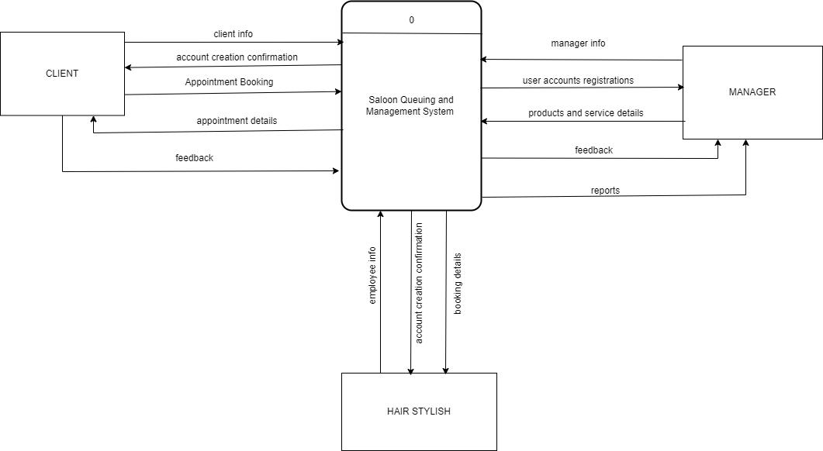

Figure 1: context diagram for salon queuing and management system.

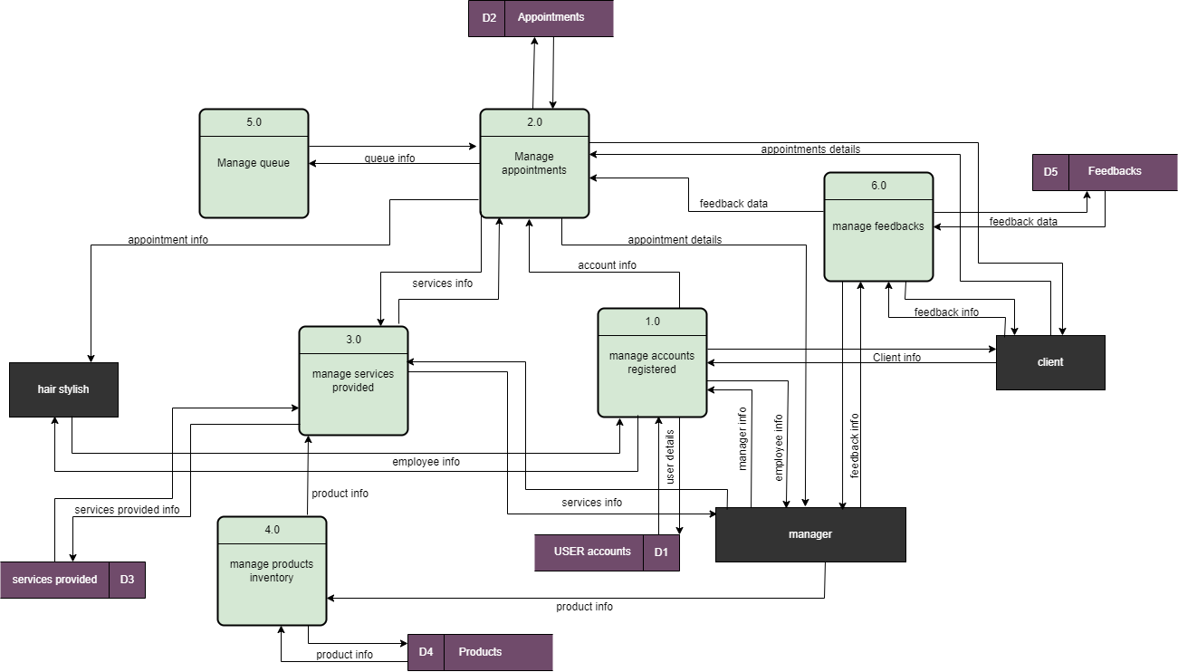

Figure 2: DFD level 0 diagram for salon queuing and management system.

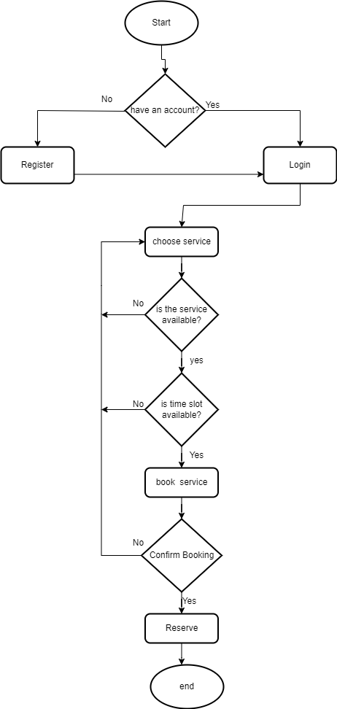

Figure 3: control flowchart diagram for salon appointment queuing algorithms.

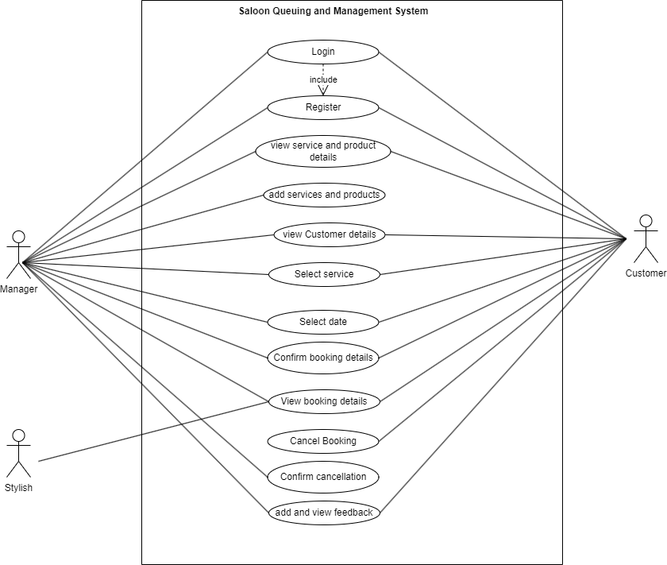

Figure 4: Use case diagram for salon queuing and management system.

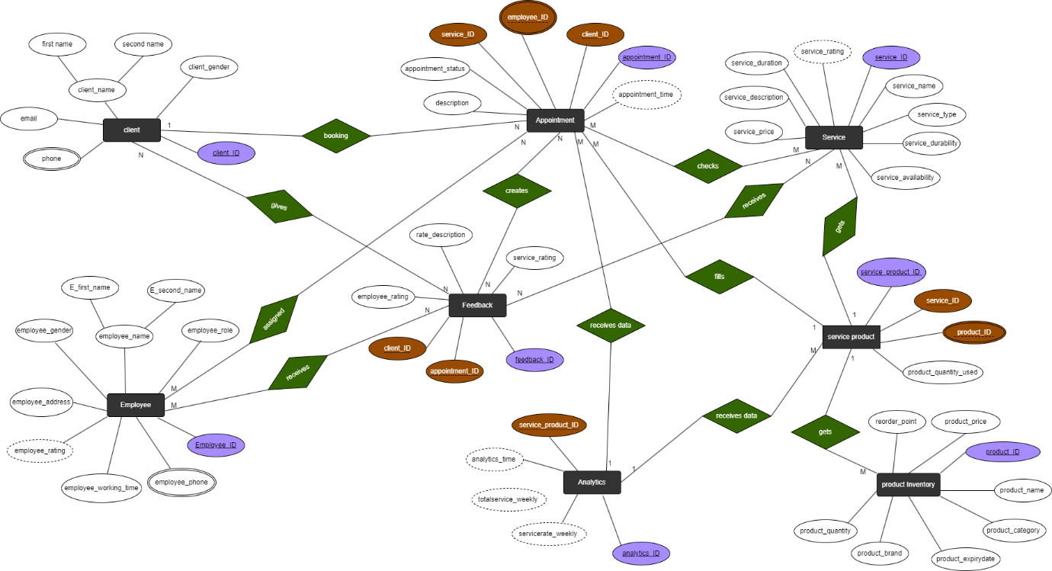

Figure 5: Use case diagram for salon queuing and management system.

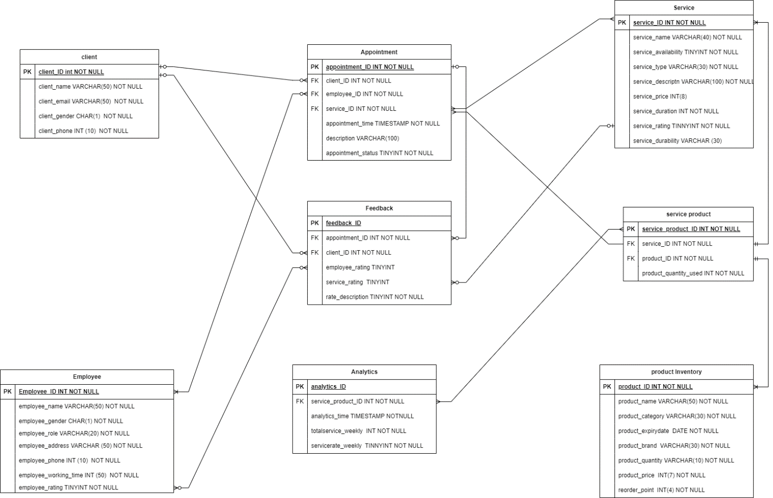

Figure 6: LOGICAL DATA MODEL for salon queuing and management system.

## SYSTEM/MODEL DESIGN/ARCHITECTURE

Designing the system/model architecture for the system involves creating a blueprint that outlines how the various components of the system interact to achieve the desired functionality. Here's an overview of the system architecture:

**1. User Interface (UI):** The user interface is the frontend of the application through which users interact with the system. It includes screens, menus, and forms that allow users to book appointments, view salon information, and provide feedback. The UI should be intuitive, visually appealing, and responsive across different devices.

**2. Application Logic Layer:** The application logic layer, also known as the backend, consists of the logic and algorithms that drive the functionality of the application. This layer handles tasks such as scheduling appointments, managing staff and inventory, sending notifications, and processing user inputs. It interacts with the database and external services to retrieve and store data.

**3. Database Management System (DBMS):** The database management system stores and manages the application's data, including customer information, appointment schedules, staff profiles, and inventory records. It ensures data integrity, security, and scalability. The DBMS can be relational (e.g., MySQL, PostgreSQL) or NoSQL (e.g., MongoDB, Firebase) depending on the requirements of the application.

**4. External Services/APIs:** The application may integrate with external services or APIs to enhance its functionality. For example, it may utilize communication APIs for sending notifications. Integration with external services should be secure, reliable, and compliant with relevant standards.

**5. Security Layer:** The security layer is responsible for ensuring the confidentiality, integrity, and availability of the application's data and functionality. It includes mechanisms such as authentication, authorization, encryption, and data validation to protect against unauthorized access, data breaches, and other security threats.

**6. Scalability and Performance Optimization:** The system architecture should be designed to accommodate growth and handle increasing loads as the application scales. This may involve implementing strategies such as load balancing, caching, and horizontal scaling to ensure optimal performance and reliability under high traffic conditions.

**7. Monitoring and Analytics:** integrating monitoring and analytics functionalities is crucial for providing salon owners with valuable insights and optimizing business operations. Here's how monitoring and analytics can be incorporated into the system design:

**i). System Components:**

* **Monitoring Module:** This module continuously gathers data from various sources within the salon management system, such as appointment booking systems, staff schedules, inventory management systems, and customer feedback platforms.
* **Analytics Engine:** The analytics engine processes the collected data to generate meaningful insights and reports. It performs tasks such as data aggregation, analysis, and visualization to provide salon owners with actionable information.

**ii). Data Collection and Integration:**

* The monitoring module collects data from diverse sources within the salon management system, including:
  + Appointment booking systems: Number of bookings, booking duration, popular time slots.
  + Staff schedules: Staff availability, utilization rates, and performance metrics.
  + Inventory management systems: Inventory levels, product sales, reordering needs.
  + Customer feedback platforms: Ratings, reviews, customer satisfaction scores.
* Data collected from these sources is aggregated and integrated into a centralized data repository for analysis.

**iii). Analytics and Reporting:**

* The analytics engine processes the collected data to generate various reports and insights, including:
  + Performance Tracking: Metrics such as revenue, customer footfall, and service utilization rates over time.
  + Resource Optimization: Analysis of staff schedules, service utilization, and inventory levels to optimize resource allocation.
  + Customer Insights: Analysis of customer behavior, preferences, and satisfaction levels to tailor services and marketing efforts.
  + Appointment Management: Real-time visibility into booking availability, staff schedules, and queue status to optimize scheduling and minimize wait times.
  + Financial Analysis: Tracking revenue, expenses, and profitability to make informed decisions about pricing, cost management, and investment strategies.
  + Operational Efficiency: Identifying opportunities for operational improvement and efficiency gains through analysis of workflow processes and performance metrics.

**iv). User Interface:**

* The user interface provides salon owners with intuitive dashboards, charts, and reports to visualize the insights generated by the analytics engine.
* Owners can customize dashboards to display relevant KPIs and metrics based on their preferences and business goals.
* Interactive features such as drill-down capabilities, filters, and alerts enable salon owners to explore data in-depth and take timely actions.

### LOGICAL DESIGN/ARCHITECTURE

The logical design architecture of the salon queueing and management system outlines the high-level structure and components of the system, focusing on its functionality and interactions. Here's an overview of the logical design architecture:

**1. Presentation Layer:**

* This layer handles user interactions and presents information to salon staff and customers.
* Components include:
  + User interfaces for staff to manage appointments, view queues, and update salon information.
  + Customer-facing interfaces for booking appointments, checking queue status, and providing feedback.
* Technologies: Web interfaces built with HTML, CSS, JavaScript, and frontend frameworks (e.g., React, Angular) for dynamic and responsive user experiences.

**2. Application Layer:**

* The application layer contains the core business logic and functionality of the queueing and management system.
* Components include:
  + Appointment scheduling module: Manages appointment booking, rescheduling, and cancellations.
  + Queue management module: Tracks customer arrivals, assigns queue positions, and updates queue status.
  + Notification module: Sends reminders, alerts, and updates to customers and staff via email, SMS, or push notifications.
* Technologies: Backend services developed using server-side programming languages (e.g., Java, Python) and frameworks (e.g., Spring Boot, Django) to implement business logic and handle data processing.

**3. Data Access Layer:**

* The data access layer interacts with the underlying data storage systems to retrieve and update salon information, appointment data, customer records, and feedback.
* Components include:
  + Database access modules: Perform CRUD operations on the database to store and retrieve data.
  + External service integrations: Interface with external systems such as mapping services, payment gateways, and communication APIs.
* Technologies: Relational database management system (RDBMS) such as PostgreSQL or MySQL for storing structured data, and ORM (Object-Relational Mapping) frameworks (e.g., Hibernate, SQL Alchemy) for database interactions.

**4. Security Layer:**

* The security layer ensures the confidentiality, integrity, and availability of the system's data and functionality.
* Components include:
  + Authentication module: Validates user credentials and controls access to system resources.
  + Authorization module: Enforces role-based access control (RBAC) to restrict user privileges based on their roles and permissions.
  + Encryption module: Protects sensitive data in transit and at rest using encryption techniques.
* Technologies: Authentication mechanisms (e.g., JWT, OAuth), encryption libraries (e.g., OpenSSL), and security frameworks (e.g., Spring Security) to enforce security policies and protect against threats.

**5. Integration Layer:**

* The integration layer facilitates communication and integration with external systems, services, or APIs.
* Components include:
  + Integration adapters: Translate data formats and protocols to facilitate communication between the queueing and management system and external services.
  + API endpoints: Expose interfaces for third-party systems to interact with the system.
* Technologies: RESTful APIs, SOAP services, message brokers (e.g., RabbitMQ), and API management platforms (e.g., Swagger) for seamless integration and interoperability.

### PHYSICAL DESIGN/ARCHITECTURE

The physical design architecture of the system focuses on the implementation and deployment aspects, detailing the hardware and software components and their configurations. Here's an outline of the physical design architecture for the system:

1. **Hardware Infrastructure:**

* Servers: Deploy physical or virtual servers to host the various components of the queue management system, such as web servers, application servers, and database servers.
* Networking Equipment: Utilize routers, switches, and firewalls to establish network connectivity and ensure secure communication between system components and external networks.
* Storage Devices: Implement storage solutions, such as hard disk drives (HDDs) or solid-state drives (SSDs), to store system data and ensure data availability and reliability.

1. **Software Infrastructure:**

* Operating Systems: Install and configure operating systems (e.g., Linux, Windows Server) on server hardware to provide a platform for running system software and applications.
* Database Management System (DBMS): Deploy a relational database management system (RDBMS) such as PostgreSQL, MySQL, or Microsoft SQL Server to store and manage system data.
* Web Server: Use web server software (e.g., Apache HTTP Server, Nginx) to host and serve web applications and provide access to clients via HTTP or HTTPS protocols.
* Application Server: Deploy application server software (e.g., Tomcat, Node.js) to run the business logic and application code of the queue management system.
* Queue Management Software: Install and configure specialized queue management software or modules to handle appointment scheduling, queue management, and notification functionalities.

1. **Scalability and Redundancy:**

* Load Balancers: Implement load balancers (e.g., HAProxy, Nginx Load Balancer) to distribute incoming traffic across multiple servers and ensure scalability and high availability of the system.
* Redundancy: Set up redundant components, such as redundant servers, databases, and network connections, to minimize single points of failure and ensure fault tolerance and business continuity.

1. **Data Storage and Backup:**

* Storage Configuration: Configure storage solutions, like cloud storage services, to ensure data integrity, availability, and performance.
* Backup and Recovery: Establish backup and recovery procedures to regularly back up system data and configurations and recover them in case of data loss or system failures.

1. **Security Measures:**

* Data Encryption: Encrypt sensitive data at rest and in transit using encryption techniques such as SSL/TLS for secure communication and data protection.
* Access Control: Enforce access control policies and role-based access control (RBAC) mechanisms to restrict access to system resources based on user roles and privileges.

## SYSTEM IMPLEMENTATION

System implementation refers to the process of translating the design specifications of a software system into a functioning and operational solution. Here's an overview of the steps involved in the implementation of the system:

**Development Environment Setup:** Set up the development environment with the necessary tools and technologies required for building the salon management system. This may include IDEs (Integrated Development Environments), version control systems, databases, and development frameworks.

### Coding

**i. Frontend Development:**

* Develop the user interfaces (UI) for the salon management system, including web interfaces for staff and customers, as well as mobile apps if applicable. Use frontend technologies such as HTML, CSS, JavaScript, and frontend frameworks to create intuitive and visually appealing UIs.

**ii. Backend Development:**

* Implement the backend functionality of the salon management system, including business logic, data processing, and integration with external systems. Develop server-side components using programming languages such as Java, Python, or Node.js, and frameworks such as Spring Boot or Django.

**iii. Database Design and Implementation:**

* Design the database schema for storing salon information, appointment data, customer records, staff schedules, and other relevant data. Implement the database structure using a relational database management system (RDBMS) such as PostgreSQL, MySQL, or SQL Server, ensuring data integrity, normalization, and efficient querying.

**iv. Integration with External Systems:**

* Integrate the salon management system with external systems and services, such as mapping services for location-based features, payment gateways for online payments, and communication APIs for sending notifications and alerts.

**v. Security Implementation:**

* Implement security measures to protect the salon management system from unauthorized access, data breaches, and other security threats. This may include authentication mechanisms, access controls, encryption techniques, and secure communication protocols.

### Testing/Evaluation

**I. Testing and Quality Assurance:**

* Conduct thorough testing of the salon management system to ensure functionality, performance, reliability, and security. This includes unit testing, integration testing, system testing, and user acceptance testing (UAT). Identify and address any defects or issues found during testing.

**II. Deployment and Release:**

* Deploy the salon management system to production environments or staging environments for final testing and validation. Coordinate with stakeholders to plan and execute the deployment process, ensuring minimal disruption to operations. Monitor the system after deployment to ensure stability and performance.

**III. Training and User Adoption:**

* Provide training and support to salon staff and customers on how to use the salon management system effectively. Encourage user adoption and gather feedback to identify areas for improvement and refinement.

**IV. Maintenance and Updates:**

* Establish procedures for ongoing maintenance, support, and updates of the salon management system. Regularly monitor system performance, address user feedback, and apply patches and updates to keep the system up-to-date and secure.

## SYSTEM REQUIREMENTS

To design and implement a successful salon queueing and management system, it's crucial to establish clear and comprehensive system requirements. Here's a breakdown of the system requirements:

1. **Functional Requirements:**
   * **Appointment Scheduling:** Allow customers to book, reschedule, or cancel appointments with salon staff.
   * **Queue Management:** Track customer arrivals, assign queue positions, and update queue status in real-time.
   * **Notification:** Send reminders, alerts, and updates to customers and staff regarding appointments and queue status.
   * **Feedback Mechanism:** Enable customers to provide ratings and reviews of salon experiences, and allow staff to respond to feedback.
   * **Inventory Management:** Track salon inventory, manage stock levels, and generate reports on product usage and sales.
   * **Services Records:** Maintain records of services provided, expenses, and revenue, and provide financial reporting capabilities.
   * **Staff Management:** Manage staff schedules, attendance, and performance metrics, and facilitate communication between staff members.
2. **Non-Functional Requirements:**
   * **Usability:** Ensure the system is intuitive and easy to use for both customers and salon staff, with a user-friendly interface and clear navigation.
   * **Performance:** Ensure the system can handle concurrent users and high transaction volumes without significant performance degradation.
   * **Reliability:** Ensure the system is highly available and resilient, with minimal downtime and robust error handling mechanisms.
   * **Security:** Implement strong security measures to protect sensitive data, including encryption, access controls, and secure communication protocols.
   * **Scalability:** Design the system to scale horizontally and vertically to accommodate growth in user base and data volume.
   * **Interoperability:** Ensure the system can integrate with external systems and services, such as mapping services, payment gateways, and communication APIs.
   * **Compliance:** Ensure the system complies with relevant regulatory requirements and industry standards, such as data protection regulations (e.g., GDPR) and payment card industry (PCI) standards.
3. **Technical Requirements:**
   * **Platform:** Select appropriate platforms and technologies for development, deployment, and hosting, considering factors such as scalability, compatibility, and vendor support.
   * **Database:** Choose a suitable database management system (e.g., PostgreSQL, MySQL) for storing and managing system data, based on performance, reliability, and scalability requirements.
   * **Programming Languages and Frameworks:** Select programming languages (e.g., Java, Python) and development frameworks (e.g., Spring Boot, Django) for building system components, based on developer expertise and project requirements.
   * **Infrastructure:** Define hardware and software infrastructure requirements, including server specifications, network configuration, and backup and recovery solutions.
   * **Integration Points:** Identify external systems and services that the system needs to integrate with, and define communication protocols and interfaces for seamless integration.

### Hardware Requirements

The hardware requirements for a salon queueing and management system depend on factors such as the scale of the salon, the expected number of concurrent users, and the desired performance and reliability levels. Here's a general outline of hardware requirements for such a system:

1. **Server Infrastructure:**
   * **Web Server:** A robust web server is needed to host the application and serve web pages to clients. Consider using servers with multi-core processors, sufficient RAM (e.g., 8GB or more), and fast storage (e.g., SSDs) to handle concurrent user requests efficiently.
   * **Application Server:** Deploy an application server to run the backend logic and business processes of the system. Similar to the web server, choosing servers with adequate processing power, memory, and storage capacity to handle application workload effectively.
   * **Database Server:** Set up a dedicated database server to host the system's database and manage data storage and retrieval operations. Ensure the database server has enough resources (CPU, RAM, storage) to handle database queries and transactions smoothly.
2. **Networking Equipment:**
   * **Firewall:** Implement a firewall to protect the network from unauthorized access and malicious attacks. Configure firewall rules to control inbound and outbound traffic and enforce security policies.
3. **Storage Devices:**
   * **Storage Arrays:** Set up storage arrays or NAS (Network Attached Storage) devices to store system data, application files, and backups. Choose storage solutions with sufficient capacity, redundancy, and performance to meet data storage and retrieval needs.
   * **Backup Devices:** Implement backup devices or solutions to regularly back up system data and configurations. Use techniques such as disk-to-disk backups or cloud backups to ensure data integrity and disaster recovery capabilities.
4. **Workstations and Client Devices:**
   * **Point-of-Sale (POS) Terminals:** Install POS terminals or workstations for salon staff to manage appointments, process payments, and access system functionalities. Ensure POS terminals are equipped with adequate processing power, memory, and peripherals (e.g., barcode scanners, card readers).
   * **Customer Kiosks or Tablets:** Provide customer kiosks or tablets for self-service appointment booking and check-in. Choose devices with user-friendly interfaces, touchscreens, and internet connectivity for seamless interaction with the system.
5. **Power Backup and Protection:**
   * **Uninterruptible Power Supply (UPS):** Install UPS devices to provide backup power in case of electrical outages or fluctuations. UPS devices help prevent data loss and system downtime by providing temporary power to critical equipment until normal power is restored.
   * **Surge Protectors:** Use surge protectors to safeguard hardware devices from power surges and voltage spikes, which can damage sensitive components and cause system failures.
6. **Environmental Considerations:**
   * Ensure that the salon's physical environment is suitable for housing and operating hardware devices. Provide adequate ventilation, cooling, and temperature control to prevent overheating and maintain optimal operating conditions for servers and networking equipment.

### Software Tools Requirements

To develop and deploy a salon queueing and management system, various software tools and technologies are required. Here's an overview of the software tools and their respective requirements:

1. **Programming Languages and Frameworks:**
   * Requirement: Select programming languages and frameworks based on project requirements and developer expertise.
   * Example Languages: Java, HTML, CSS, JavaScript.
   * Example Framework: React.
2. **Database Management System (DBMS):**
   * Requirement: Choose a DBMS suitable for storing and managing system data.
   * Example Tool: MySQL.
3. **Web Server:**
   * Requirement: Deploy a web server to host and serve the application to clients.
   * Example Tool: Apache HTTP Server
4. **Application Server:**
   * Requirement: Utilize an application server to run backend logic and processes.
   * Example Tools: Apache Tomcat, Node.js.
5. **Frontend Development Tools:**
   * Requirement: Use tools for frontend development to create interactive and responsive user interfaces.
   * Example Tools: HTML, CSS, JavaScript, React, Angular, Vue.js.
6. **API Development and Documentation:**
   * Requirement: Develop and document APIs for integrating with external systems and services.
   * Example Tool: OpenAPI.
7. **Testing Frameworks:**
   * Requirement: Implement testing frameworks for automated testing of system components.
   * Example Tools: JUnit, Mockito, Selenium, Cypress.
8. **Monitoring and Logging Tools:**
   * Requirement: Utilize tools for monitoring system performance and collecting logs for troubleshooting.
   * Example Tools: Prometheus, Grafana, ELK Stack (Elasticsearch, Logstash, Kibana).
9. **Project Management and Collaboration Tools:**
   * Requirement: Use tools for project management, task tracking, and team collaboration.
   * Example Tool: Microsoft Teams.
10. **Documentation Tools:**
    * Requirement: Create documentation for system architecture, design, and user guides.
    * Example Tools: Microsoft Word, Markdown editors.

# CHAPTER 4

PROJECT TIMELINE AND BUDGET

## Project timeline

This is the chronological order of events that involve dates and events reflecting project progress from the start of an activity to its completion.

A Gantt chart is the most reliable tool for creating a project timeline.

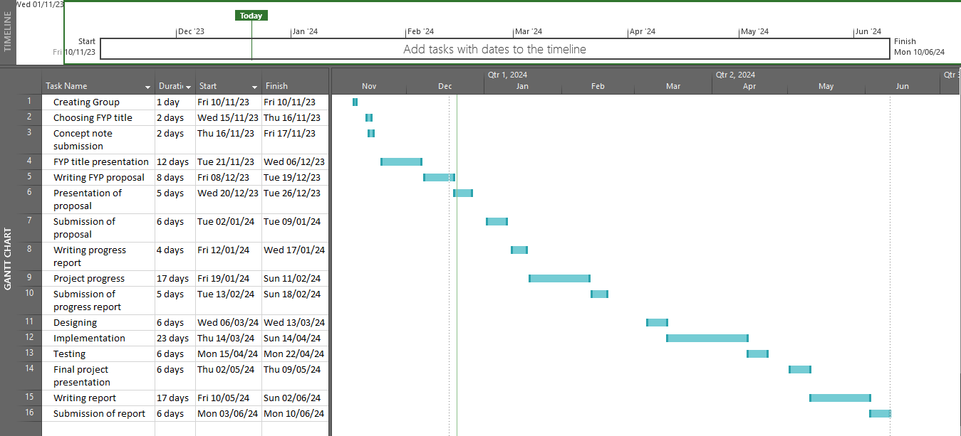

## Project Budget

A project budget is a tool used by the project management team to estimate, allocate, and track financial resources necessary for the successful planning, execution, and completion of a project. It serves as a comprehensive financial plan that outlines the anticipated costs associated with project activities, resources, and deliverables. The project budget plays a crucial role in guiding financial decision-making, controlling expenses, and ensuring that the project is completed within the approved financial constraints

|  |  |  |
| --- | --- | --- |
| **S/N** | **Item** | **Costs** |
|  | Stationaries | 50,000/= |
|  | Domain Registration | 50,000/= |
|  | Survey | 50,000/= |
|  | Initial support to clients | 50,000/= |
|  | Hosting | 40,000/= |
|  | Testing and Quality Assurance | 60,000/= |
|  | Miscellaneous Expenses | 70,000/= |
|  | **Total** | **370,000/=** |

## REFERENCES

Choi, J., Lee, S., & Kim, J. (2019). The effects of staff training programs on service quality and customer satisfaction in beauty salons. Journal of Retailing and Consumer Services, 50, 81-89. doi:10.1016/j.jretconser.2019.04.011

Kim, H., Park, J. E., & Kim, Y. (2018). Effective inventory management for beauty salon businesses: A case study. Journal of Retailing and Consumer Services, 40, 101-108. doi:10.1016/j.jretconser.2017.09.015

Nguyen, T. T., & Le, N. T. (2019). The impact of service quality and customer satisfaction on customer loyalty in beauty salons: The moderating role of queue problems. Journal of Retailing and Consumer Services, 48, 274-282. doi:10.1016/j.jretconser.2019.02.015

Yoon, S., Lee, H. J., & Kim, J. (2020). The role of customer relationship management (CRM) system in enhancing customer satisfaction: The case of beauty salons. Journal of Retailing and Consumer Services, 54, 102042. doi:10.1016/j.jretconser.2019.102042

Back, K. J., Lee, H. J., & Kim, J. (2017). Service quality, customer satisfaction, and customer loyalty in mobile telecommunication services: The moderating role of queue problems. Journal of Retailing and Consumer Services, 34, 70-75. doi:10.1016/j.jretconser.2016.09.007